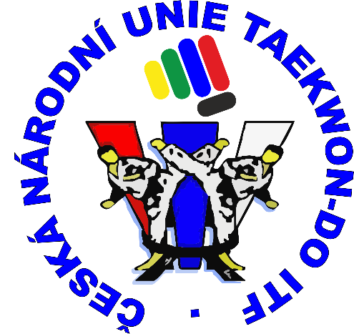

**Invitation**

**Czech Republic Championship**

**Taekwon-Do ITF 2015**



Czech National Taekwon-Do Union

in cooperation with Sokol Benátky nad Jizerou

hold

Open Championship of Czech Republic

Taekwon-Do ITF 2015

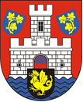

**Date of event: 16th May 2015**

**Place of event: Sporthall ZŠ Benátky nad Jizerou, streeet 5. kvetna 746**

**GPS: 50°17´12.733 N, 14°49´45.082 E**

**Let us invite you to Open Championship of Czech Republic,   
organizer Czech National Taekwon-Do Union.**

**This competition is hosted by beautiful town in central Bohemia Benátky nad Jizerou on 16th May 2015 in nice sporthall**

**We would like to invite all Taekwon-Do competitors from Czech Republic.**

**Event schedule:**

Open of sporthall 8.00

Registration 8.00 – 9.45

Refferees and coaches meeting 9.45 – 10.00

Start of competition 10.00

Expected end 18.00

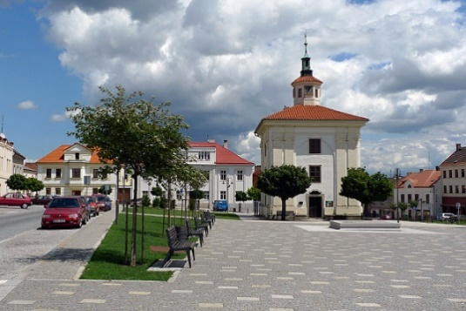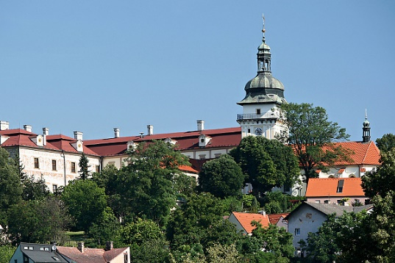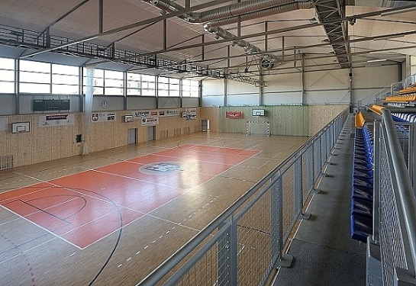

**More information you can find in attached instructions and on website of CzNTU.**

**We are looking forward for all participants**

**International instructor Viktor Stein IV.Dan**

**President CzNTU**

**International instructor Ing. Kamil Kolofík IV.Dan**

**Chairman of Technical committee CzNTU**

**[www.taekwondocz.com](http://www.taekwondocz.com) |** [**technicka@taekwondocz.com**](mailto:technicka@taekwondocz.com)